Product Review Analysis System
CHAPTER 1: INTRODUCTION
1.1 Background
In the contemporary digital marketplace, product reviews serve as a crucial feedback mechanism for both businesses and consumers. For businesses, reviews offer a direct line to understanding customer needs, identifying product flaws, and gauging market perception. For consumers, they act as social proof, influencing purchasing decisions. The sheer volume of reviews on platforms like Amazon, Flipkart, and Yelp has made it humanly impossible to manually process this data for meaningful insights. This challenge has created a significant demand for automated solutions that can analyze large datasets of unstructured text.
Our project addresses this need by developing a system that leverages advanced NLP techniques to perform sentiment analysis on product reviews. The system will automate the process of data collection, cleaning, and analysis, providing a structured output that highlights key sentiment trends and popular topics. This project is not merely an academic exercise; it has direct, real-world applicability in business intelligence, marketing, and product development.
- Data Acquisition and Preprocessing: Create a system to get and clean unstructured product reviews from a Kaggle dataset, making the text ready for analysis.
- Sentiment Analysis Model Development: Build a machine learning model that can accurately sort reviews into positive, negative, or neutral categories.
- Feature and Keyword Extraction: Find the key words and phrases in reviews that are most connected with either positive or negative feelings, to better understand what customers like or don't like.
- Data Visualization and Reporting: Make interactive charts and dashboards to clearly show the results of the analysis, including sentiment trends and keyword frequency.
- Database Integration: Design and use a SQL database to store and organize the review data and the results of the sentiment analysis.

1.3 Purpose, Scope, and Applicability

1.3.1 Purpose
The purpose of this project is to provide a robust, automated system that transforms raw, unstructured product review data into actionable business intelligence. It serves as a proof-of-concept for how businesses can leverage text analytics to gain a competitive advantage by listening to their customers at scale.

1.3.2 Scope
The scope of this project is focused on the analysis of text-based product reviews. It will use a publicly available dataset from Kaggle. The project will cover the entire workflow from data ingestion to visualization. It will not, however, include real-time data scraping from live websites, as this is beyond the scope of a final year academic project and requires handling complex web scraping protocols and legal considerations. The project is designed to be a modular and scalable prototype.

1.3.3 Applicability
The developed system is applicable to a wide range of industries and business functions.
- Product Development: Engineers and product managers can use the system to identify recurring issues or popular feature requests.
- Marketing & Branding: Marketing teams can monitor brand perception and understand customer sentiment regarding campaigns.
- Customer Support: Support teams can prioritize customer feedback and address common complaints more efficiently.
- Market Research: Analysts can use the insights to gauge market trends and analyze competitor products.

  - Achievements
The successful implementation of the project will achieve the following outcomes:
- Develop a scalable data pipeline capable of handling large datasets.
- Implement a multi-class sentiment analysis model with high accuracy and a low false positive rate.
- Design a relational database schema that efficiently stores and retrieves structured data.
- Create a user-friendly interface for visualizing analysis results.
- Demonstrate proficiency in a modern technology stack, including Python, Flask, SQL, and various machine learning libraries

.
1.5 Organization of Report
This report is structured to provide a logical and comprehensive
overview of the project
- Chapter 1: Introduction – Project background, objectives, purpose, scope, applicability, achievements.
- Chapter 2: Survey of Technologies – Overview of frontend, backend, and database technologies used.
- Chapter 3: Requirement and Analysis – Detailed problem definition, requirement specification, and planning, UML Diagrams.
- Chapter 4: System Design –Module design, and architecture of the system, Security Issues, Test Cases.

Chapter 2 - Survey of Technologies
2.1 Introduction
The development of the Product Review Analysis System requires a careful selection of technologies across frontend, backend, database, and machine learning domains. This chapter provides a detailed survey of these technologies, highlighting their features, advantages, disadvantages, and the justifications for their selection. The survey ensures that the system is built on a modern, scalable, and secure stack capable of efficiently handling large datasets and complex text analysis tasks.
The technologies are grouped into categories for better understanding: frontend, backend, database, and machine learning libraries.

2.2 Frontend Technologies
Frontend technologies manage the user interface and user experience of the application. Since this system involves displaying visualizations and dashboards, the frontend must be responsive, lightweight, and intuitive.
- HTML5:HTML5 is the structural backbone of the web pages, providing elements for organizing content and integrating visualizations.
- CSS3:CSS3 handles the visual presentation of the platform, ensuring a clean layout and responsive design that adjusts for different screen sizes.
- JavaScript The main scripting language of the web, JavaScript enables dynamic interactions and controls for features like interactive charts and report generation. It handles requests for seamless communication with the backend server.

2.3 Backend Technologies
The backend is the engine of the system, responsible for all data processing, model execution, and database communication.
- Python Python was selected as the primary backend language due to its dominance in data science and machine learning. Its extensive ecosystem of libraries, including Scikit-learn, NLTK, and Pandas, makes it the ideal choice for this project.
- Flask A lightweight micro-framework for Python, Flask is used for building the web application's backend. It provides just the essential tools for managing routing and APIs, allowing for rapid development and flexibility in integrating the data analysis and machine learning components.

2.4 Database Technologies
The system requires an efficient database to store structured data like product information, reviews, and analysis results.
- SQLite A lightweight, serverless relational database management system (RDBMS) that is ideal for the prototype phase of this project. It is easy to set up and manage, and its SQL capabilities are perfect for storing and retrieving structured data.
- MySQL (or PostgreSQL) These relational databases are suitable for production environments. They store structured data such as user accounts, review metadata, and analysis results, ensuring data integrity and supporting complex queries.

2.5 Machine Learning Libraries
The core of the system relies on powerful machine learning and natural language processing (NLP) libraries.
- NLTK (Natural Language Toolkit) Used for fundamental NLP tasks such as tokenization, stop-word removal, and stemming, which are essential steps in preparing the text data for analysis.
- Pandas A powerful library for data manipulation and analysis, used for handling and cleaning the large review datasets.

2.6 Summary
The selected technologies form a robust and cohesive ecosystem for the Product Review Analysis System. The chosen stack balances performance, scalability, and ease of development. The system utilizes Python with Flask for a strong backend, a relational database for structured data, and a suite of powerful machine learning libraries to ensure accurate sentiment analysis. This survey validates that the selected stack is optimal for building a scalable, secure, and customizable text analysis platform.

CHAPTER 3: REQUIREMENTS AND ANALYSIS
3.1 Problem Definition
In the modern digital economy, online product reviews have become an invaluable source of customer feedback, influencing purchasing decisions and providing businesses with direct insights into product performance and market sentiment. However, the sheer volume and unstructured nature of this data pose a significant challenge. Manually sifting through thousands or even millions of reviews to extract meaningful insights is not only inefficient but also prone to human error and subjectivity. This project addresses this critical gap by developing an automated Product Review Analysis System. The system aims to transform this vast, qualitative data into structured, quantitative, and actionable intelligence, empowering businesses to make informed decisions and improve their products and services.
The key problems this project seeks to solve are:
- Data Overload: The inability to manually process the massive volume of reviews generated on e-commerce platforms.
- Lack of Structure: The unstructured nature of text data, which makes traditional database and reporting methods ineffective.
- Inefficient Analysis: The time-consuming and manual process of gauging customer sentiment from reviews.
- Poor Decision-Making: The failure to leverage customer feedback, leading to missed opportunities for product improvement and market strategy.
- Limited Scalability: Existing manual methods that cannot scale to accommodate an ever-increasing flow of new reviews.

3.2 Requirements Specifications

3.2.1 System Requirements
- Functional Requirements:
  - Data Ingestion: The system must allow users to upload product review data in common formats (e.g., CSV, JSON).
  - Data Preprocessing: It must automatically clean and preprocess raw text data by removing noise, handling case, and normalizing text.
  - Sentiment Analysis: The system must classify each review as "positive," "negative," or "neutral" using a machine learning model.
  - Keyword/Feature Extraction: It must identify and extract key terms and features that are most relevant to each sentiment category.
  - Database Integration: The system must store raw data, preprocessed text, and analysis results in a structured SQL database.
  - Visualization and Reporting: The system must generate and display visualizations (e.g., charts, graphs) of the analysis results in a user-friendly dashboard.
  - User Management: The system must include a secure authentication system for user registration, login, and access control.
- Non-Functional Requirements:
  - Performance: The system should process large datasets efficiently, with an acceptable processing time for a given volume of reviews.
  - Scalability: The architecture must be scalable to handle an increasing volume of data and new features.
  - Reliability: The system should be robust and stable, with minimal downtime.
  - Usability: The user interface should be intuitive and easy to navigate for non-technical users.
  - Security: Data privacy and integrity must be maintained through secure connections and access controls.

3.3 Planning and Scheduling
The project will follow an agile development methodology, organized into a series of sprints.
The major project phases are:
- Requirement Analysis & Feasibility Study
- System Design (UI/UX, database schema, architecture)
- Data Acquisition & Preprocessing Pipeline Development
- Machine Learning Model Development & Training
- Backend & API Development
- Frontend & Visualization Development
- System Integration & Comprehensive Testing
- Documentation & Final Deployment

3.4 Hardware and Software Requirements
- Hardware:
  - Processor: Intel Core i5 (8th Gen or equivalent) or higher.
  - RAM: Minimum 8 GB (16 GB recommended for handling large datasets).
  - Storage: At least 256 GB SSD for fast data access.
  - Network: A stable internet connection for downloading libraries and data.
- Software:
  - Operating System: Windows 10/11, macOS, or Linux.
  - Programming Language: Python 3.9+
  - Web Framework: Flask
  - Database: SQLite for local development, with an option to scale to PostgreSQL for production.
  - Version Control: Git & GitHub
  - Development Tools: Visual Studio Code, Jupyter Notebook
  - Key Libraries: pandas, scikit-learn, nltk, matplotlib, seaborn

3.4.1 Gantt Chart
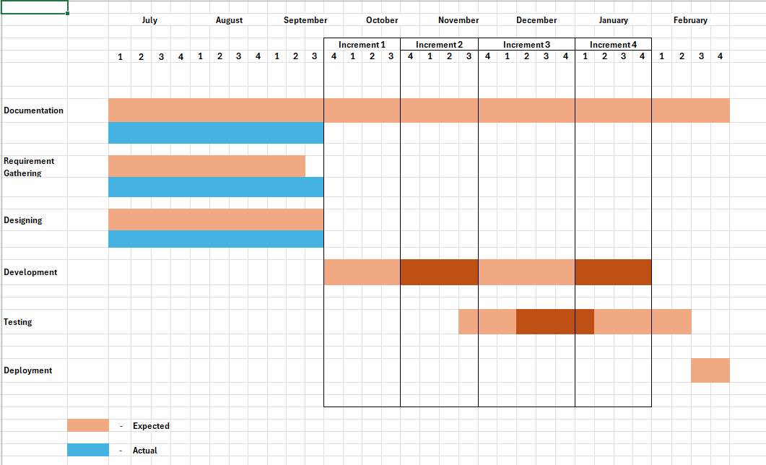

3.5 Product Description

The system is built on a modular architecture, with a clear separation of concerns to enhance scalability and maintainability. Its primary components include:
- Data Ingestion Module: Responsible for securely accepting and validating uploaded review files.
- Preprocessing Module: A dedicated component for text cleaning and normalization.
- Analysis Module: The core engine that houses the trained sentiment analysis model and performs the classification.
- Database Module: Manages all interactions with the SQL database, ensuring data persistence and integrity.
- Web Module: The user-facing component that handles user authentication and renders the interactive dashboards and reports.

3.6 Conceptual Design
3.6.1 Use Case Diagram
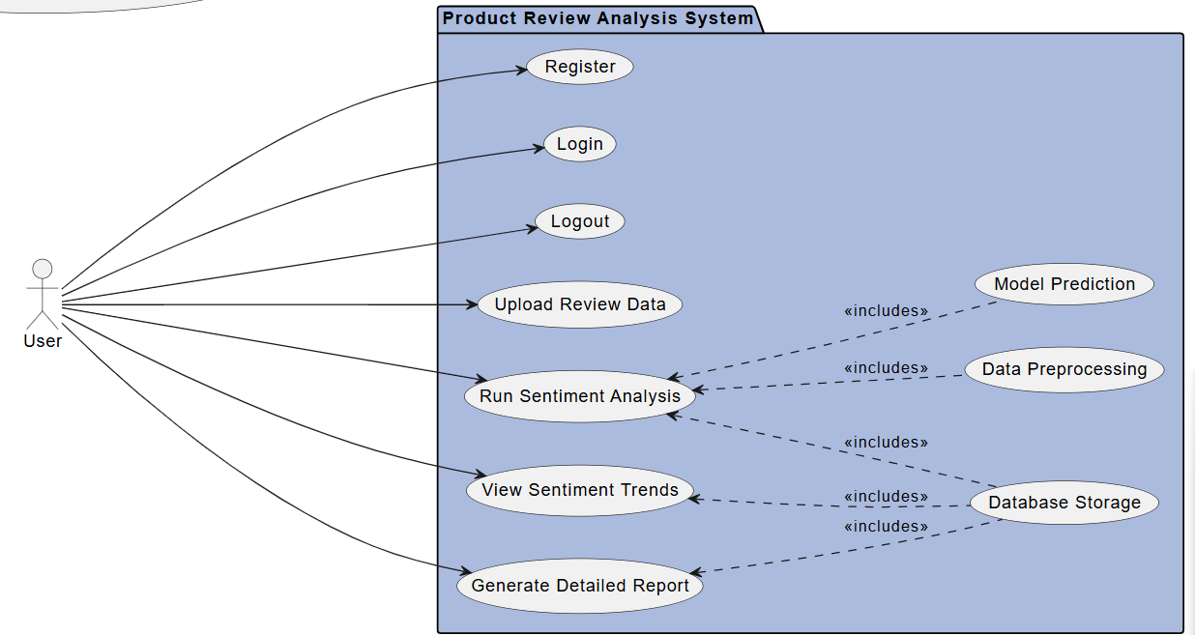

3.6.2 ER Diagram:

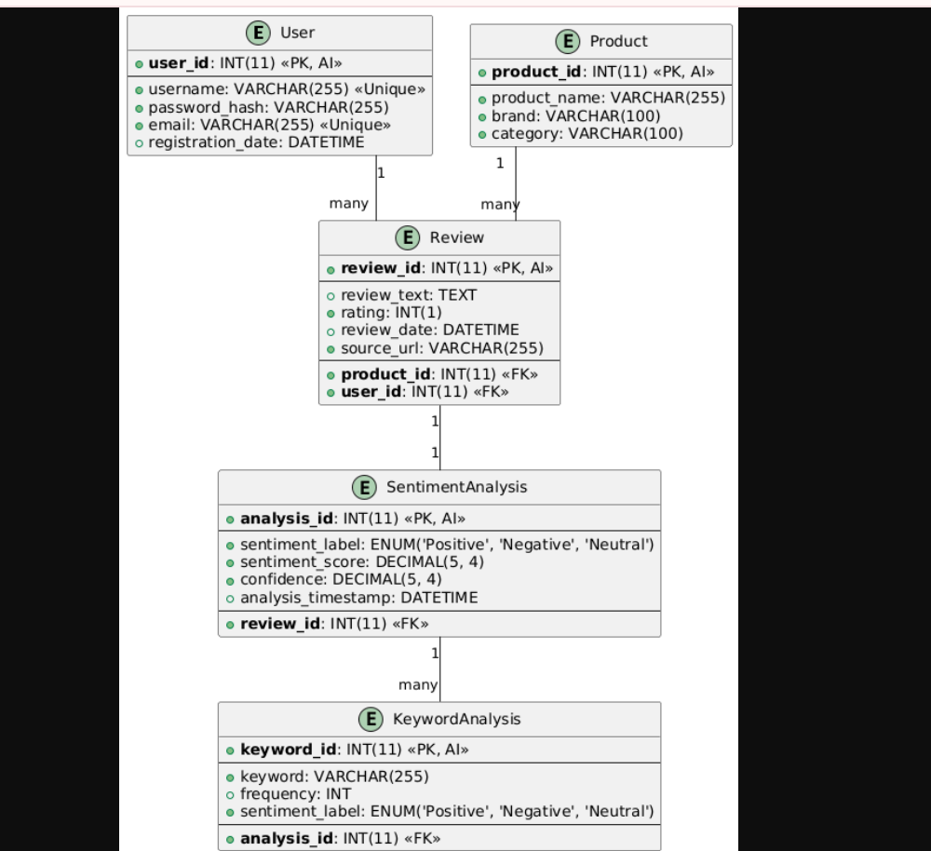

3.6.3 Sequence Diagram

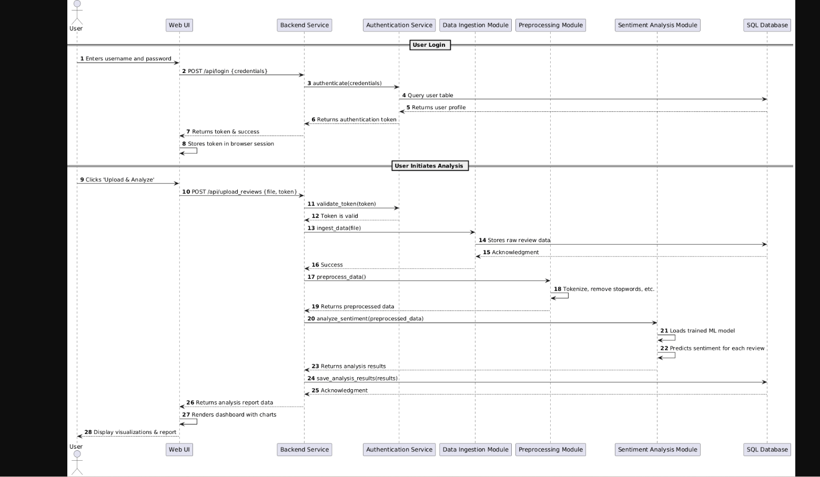

3.6.4 Class Diagram
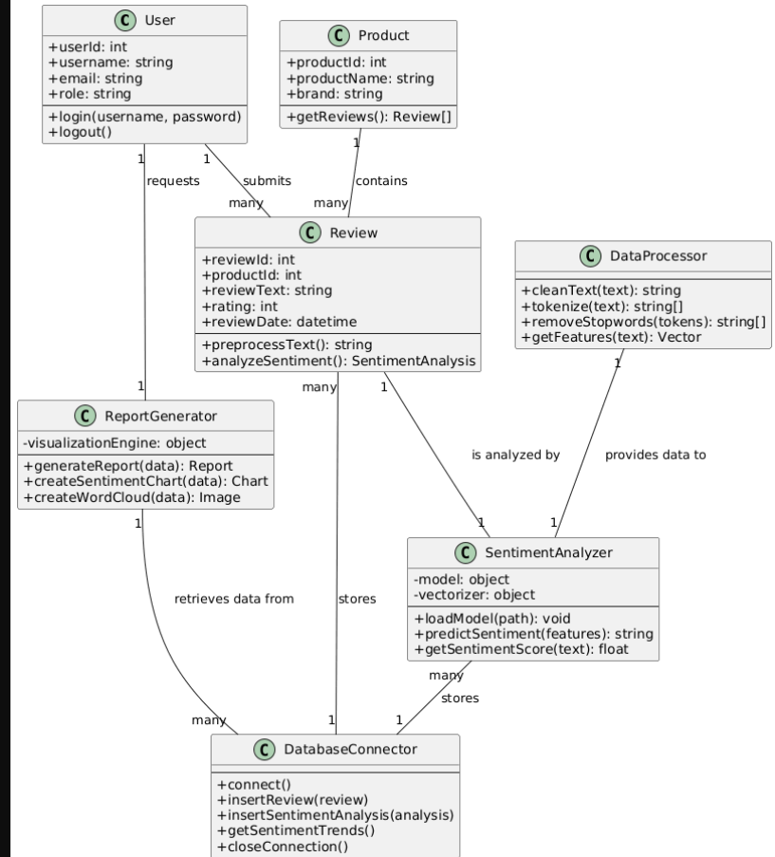

3.6.5 Data Flow Diagram (DFD)
LEVEL 0
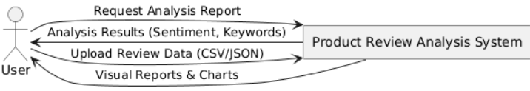

LEVEL 1
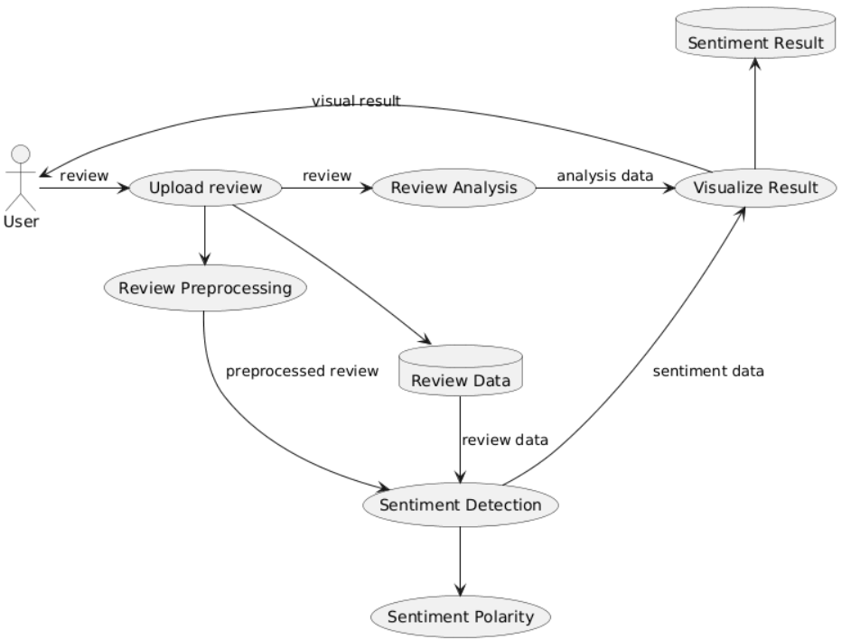

LEVEL 2

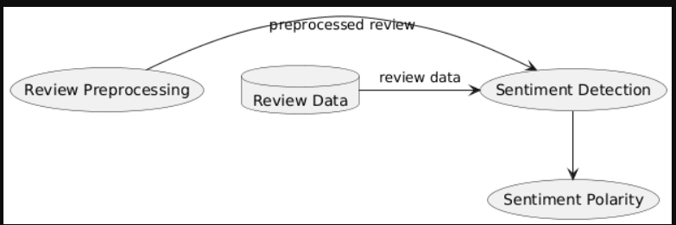

Chapter 4 - System Design
4.1 System Architecture
The Product Review Analysis System is designed using a client-server architecture. The front-end is responsible for the user interface, allowing users to upload data and view reports. The back-end handles all the core logic, including data ingestion, analysis, and storage. This design ensures a clear separation of concerns, improving the system's scalability and maintainability. The system uses a centralized database to manage all review data and analysis results.

4.2 Module Design
The system is organized into several key modules that work together to process and present review data:
- Data Ingestion Module: This module handles the process of accepting raw review data from users, validating its format (e.g., CSV, JSON), and storing it in the reviews database table.
- Data Processing & Analysis Module: This is the core of the system. It retrieves raw review text, performs preprocessing (cleaning, tokenization), and applies machine learning models for sentiment analysis and keyword extraction. The results are then stored in the sentiment_analysis and keyword_analysis tables.
- Reporting & Visualization Module: This module fetches processed analysis results from the database to generate and display reports and visualizations, such as sentiment distribution charts and word clouds. It provides the final output for the user.
- User Management Module: Manages user authentication, including registration and login, ensuring secure, role-based access to the system's functionalities.

4.3 DATABASE DESIGN

1. Users Table
Field Name | Data Type | Constraints | Description
id | INTEGER | Primary Key, Auto Increment | Unique user ID
username | TEXT | UNIQUE, NOT NULL | Login name
email | TEXT | UNIQUE, NOT NULL | User’s email
password | TEXT | NOT NULL | Encrypted password
role | TEXT | CHECK (‘admin’, ‘user’), Default = ‘user’ | User role
created_at | DATETIME | Default = CURRENT_TIMESTAMP | Registration date

2.Products Table
Field Name | Data Type | Constraints | Description
id | INTEGER | Primary Key, Auto Increment | Product ID
name | TEXT | UNIQUE, NOT NULL | Product name
category | TEXT | NULL allowed | Product category
created_at | DATETIME | Default = CURRENT_TIMESTAMP | Added date

3. Reviews Table
Field Name | Data Type | Constraints | Description
id | INTEGER | Primary Key, Auto Increment | Review ID
review_text | TEXT | NOT NULL | User’s review text
sentiment | TEXT | CHECK (‘Positive’, ‘Negative’, ‘Neutral’) | Analyzed sentiment
score | REAL | NULL allowed | Sentiment polarity score (-1 to +1)
created_at | DATETIME | Default = CURRENT_TIMESTAMP | Review date
user_id | INTEGER | Foreign Key → users(id), NOT NULL, ON DELETE CASCADE | Reviewer (who submitted)
product_id | INTEGER | Foreign Key → products(id), ON DELETE SET NULL | Product being reviewed

4.Sentimental_analysis Table
Field Name | Data Type | Constraints | Description
id | INTEGER | Primary Key, Auto Increment | Unique sentiment analysis record ID
review_id | INTEGER | Foreign Key → reviews(id), NOT NULL, ON DELETE CASCADE | The review that was analyzed
method | TEXT | NOT NULL (e.g., ‘TextBlob’, ‘VADER’) | Algorithm/library used
polarity_score | REAL | NULL allowed | Polarity value (-1 to +1)
subjectivity | REAL | NULL allowed | Subjectivity score (0 = objective, 1 = subjective)
compound_score | REAL | NULL allowed | VADER compound score
sentiment_label | TEXT | CHECK (‘Positive’, ‘Negative’, ‘Neutral’) | Final sentiment category
analyzed_at | DATETIME | Default = CURRENT_TIMESTAMP | Time when analysis was performed

5.Keyword_analysis Table
Field Name | Data Type | Constraints | Description
id | INTEGER | Primary Key, Auto Increment | Unique keyword analysis record ID
review_id | INTEGER | Foreign Key → reviews(id), NOT NULL, ON DELETE CASCADE | The review being analyzed
keyword | TEXT | NOT NULL | Extracted keyword
frequency | INTEGER | NOT NULL | Count of keyword in the review
importance | REAL | NULL allowed | TF-IDF or weight score
sentiment_hint | TEXT | CHECK (‘Positive’, ‘Negative’, ‘Neutral’) NULL allowed | If keyword reflects sentiment meaning
analyzed_at | DATETIME | Default = CURRENT_TIMESTAMP | Time when keyword extraction was done

4.4 User Interface


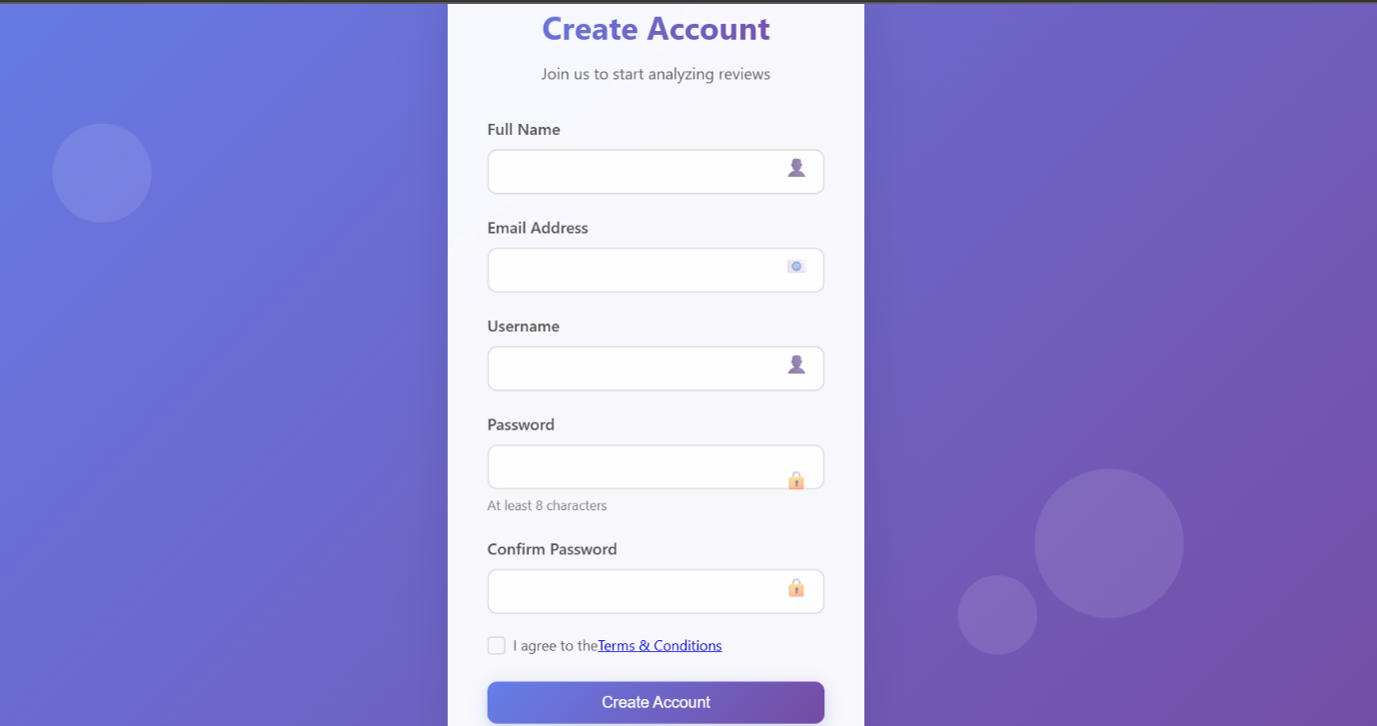

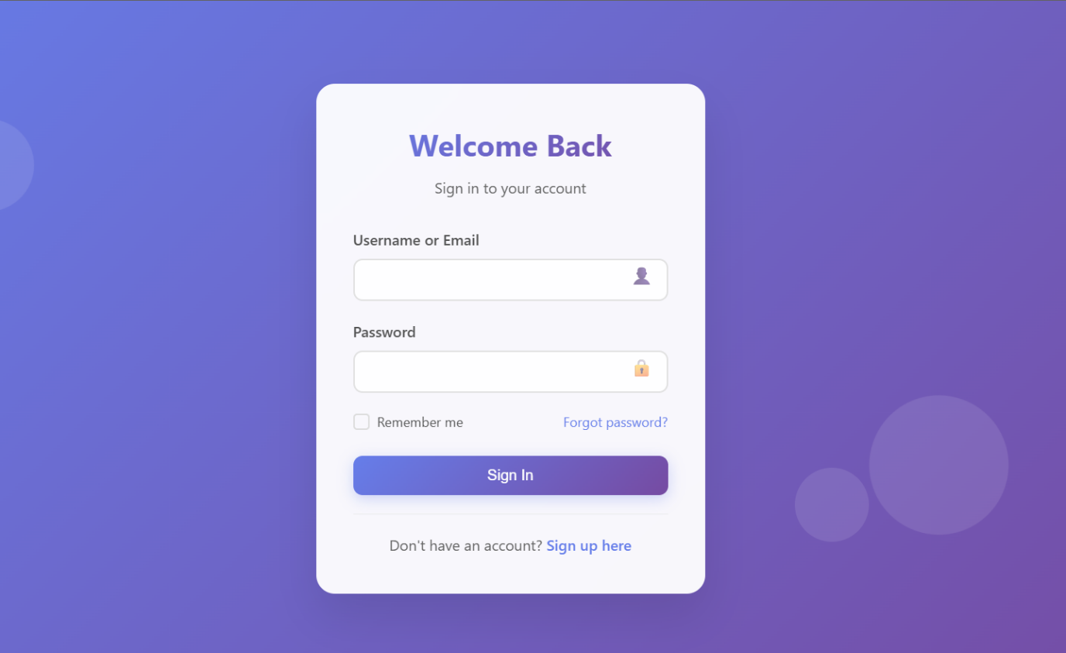

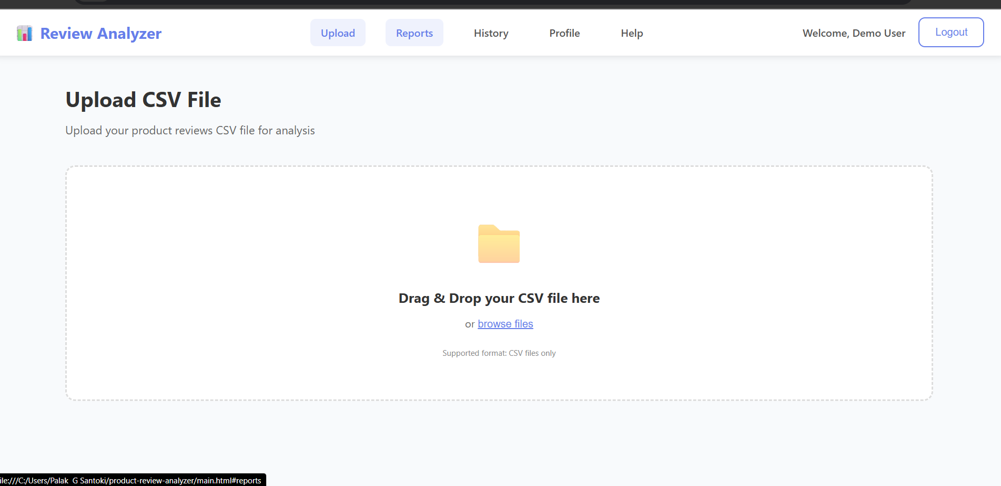

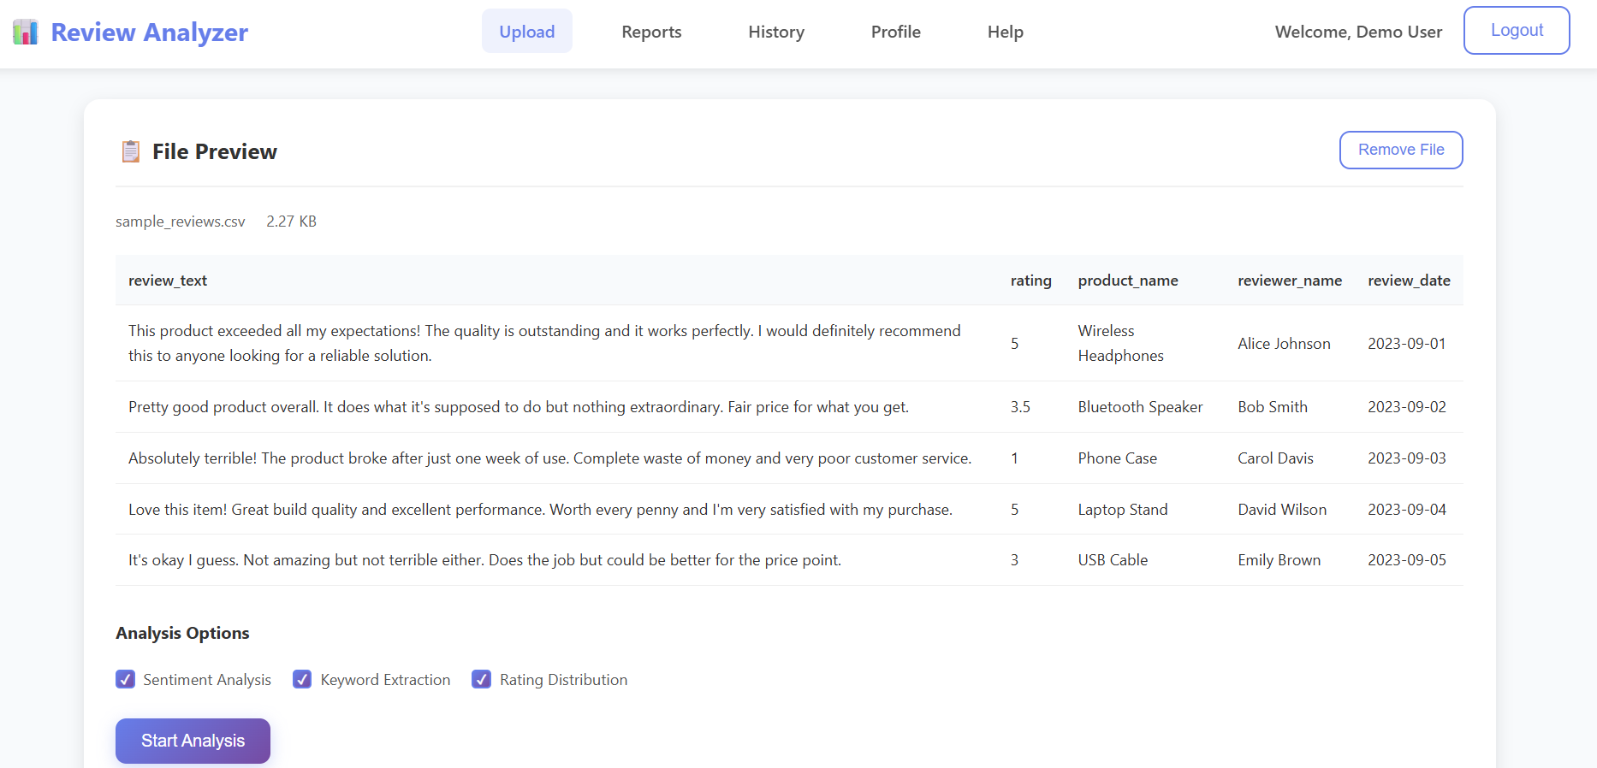

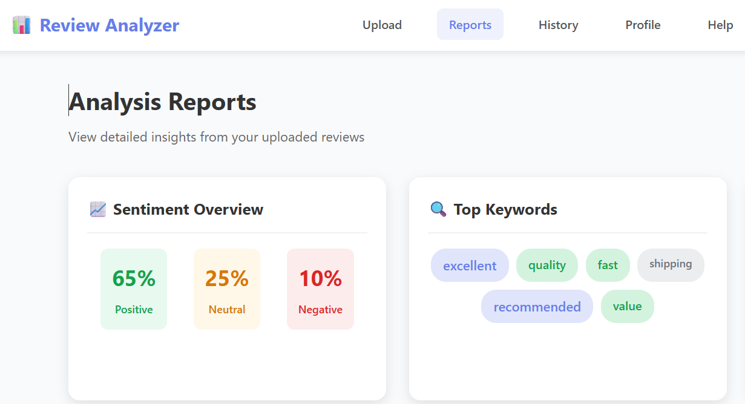
4.5 Security Issues
Several security considerations are crucial for this project:
- Authentication and Access Control: The system must use secure methods for storing passwords (e.g., hashing) and implement role-based access to ensure that only authenticated users can upload data or view their own reports.
- Data and Input Validation: To prevent security threats like SQL Injection, all user inputs, especially uploaded data, must be rigorously validated and sanitized before being processed or stored in the database.
- Data Privacy: User review data should be handled securely, and access to this data should be restricted to prevent unauthorized viewing or manipulation.

4.6Test Case
Test Case ID | Module | Test Scenario | Input | Expected Output
TC-01 | User Registration | Register with valid details | Username, Email, Password | Account created
TC-02 | User Registration | Register with duplicate email | Already used email | Error shown
TC-03 | User Login | Login with correct details | Valid Email & Password | Dashboard opens
TC-04 | User Login | Login with wrong password | Invalid password | Error shown
TC-05 | Review Submission | Submit valid review | Review text = "Product is amazing" | Review stored
TC-06 | Review Submission | Submit empty review | Review text = "" | Error shown
TC-07 | Sentiment Analysis | Positive review | "Great product" | Sentiment = Positive
TC-08 | Sentiment Analysis | Negative review | "Worst quality" | Sentiment = Negative
TC-09 | Keyword Analysis | Extract keywords | "Camera quality is bad" | Keywords: camera, quality
TC-10 | Dashboard | Admin views reviews | Admin login | All reviews displayed

